Prelude – I will call upon the Lord Loretta Ellis

Words of Welcome

╬ Call to Worship
We gather this day to refresh
We bring thoughts of our Lord
As we gather this day to refresh
Our minds focus on the Lord
As we gather this day to refresh
We join with each other to sing his Praises. Amen
╬ Passing the Peace
All may greet one another in the name of the Lord.
╬ Immortal, Invisible, God Only Wise, № 103
Joys & Concerns
Pastoral Prayer

The Lord’s Prayer

Children’s Time

╬ Prayer for Illumination
God of all help us to remember those who guided us along our path in order for us to become your loving children. Watch over them and guide them in your wisdom.

Scripture: Deuteronomy 32:7

╬ Gloria Patri № 70

Special Speaker: John Sheehan Message: “Opal”

Moments of Reflection

╬ Blessed Assurance № 369
Tithes and Offerings
Offertory – Freely, Freely Loretta Ellis
╬ Doxology № 95

╬ Prayer of Dedication
As you follow Christ and this congregation do not be afraid to pass along words of comfort that you have gleaned from, any worship that shouts to you: “pass me on”

╬ Blessed Be the Name № 63 (twice)

╬ Connections

╬ Benediction
Go now in the light of Christ, who came to save and not condemn. Walk in His truth, love and grace.
May God’s light shine through us into the world as we go to serve the Lord. Amen!

Postlude – Hymn of Promise Loretta Ellis

CALENDAR OF EVENTS – WEEK OF June 14th- June 20th
Today 9:30 am Sunday Worship| Women’s Sunday
Special Speaker: John Sheehan
June 15th 4:45 pm Boot Camp at Calvary Life Center
June 16th 8 am & 4:45 pm Boot Camp at Calvary Life Center
6:30 pm Boy Scouts at Calvary Life Center
June 17th 8am & 4:45pm Boot Camp at Calvary Life Center
6:30 pm Cub Scouts @ Calvary Life Center
June 18th 8am & 4:45pm Boot Camp at Calvary Life Center
1:00 pm Prayer Shawls at Wesley UMC
4:00 pm TOPS at Calvary Life Center
June 19th 8:00 am Boot Camp at Calvary Life Center
All Day Offices Closed | Juneteenth Celebrations
June 20th

OUR PRAYERS AND THOUGHTS
Please be in prayer for: Uniontown UMC. Pastor Jillian Goodwin
Continuing Prayers: Lori Ensminger, Spencer & Helen Ambler, Fred Church, Debbie Spait, Susan Catron, Chris Callier, Beverly Franklin, Terry & Sandy Rodgers, Jerry Smith, David Wichman, Sandy Wolf - Buche, Vernon Miller, Maria (infant great-granddaughter of Larry & Pam Hart), Vic Edwards (Son-in-Law of Marvin & Donna Valentine), Craig Sargeant (Brenda Sargeant’s Son), Jack Stanley, Linda Johnson, Jeff Jackson (Norma Jackson’s Son), Matt Schwenk (Karen Lee’s Son-in-law), Penny Miller (Joann Miller’s Daughter), Becky Rourk, Donna Beebe, Bill Mentzer(Shellie Regehr’s Uncle), Yvonne Dunlap.
Care Home Residents: Baldwin Rehab: Cheryl Moyer. Greystone: Barbara Letsinger, Kathleen Sinclair, Dianna Cuppy, Eleanor Ross, Deanna Buche- Wright. Oswego Health & Rehab: Lois Kerns, Pittsburg Health & Rehabilitation: Jan Powell Credo Senior Living: Ken Groves. Dignity Care Home: Joann Maxwell Heartland: Jean Roberts.
Hometouch: Debbi Sebbert, Don & Frances Wiles, Betty & Jerry Skidmore.

Pastor Owen is available by phone (620.228.1976), text, or email
(iolawesleypastor@gmail.com) Monday - Thursday during his office hours 9:00 - 3:30. After
hours, for emergency only. All prayer requests should be submitted to the church office by phone at 620.365.2285 or by email iolawesley@gmail.com

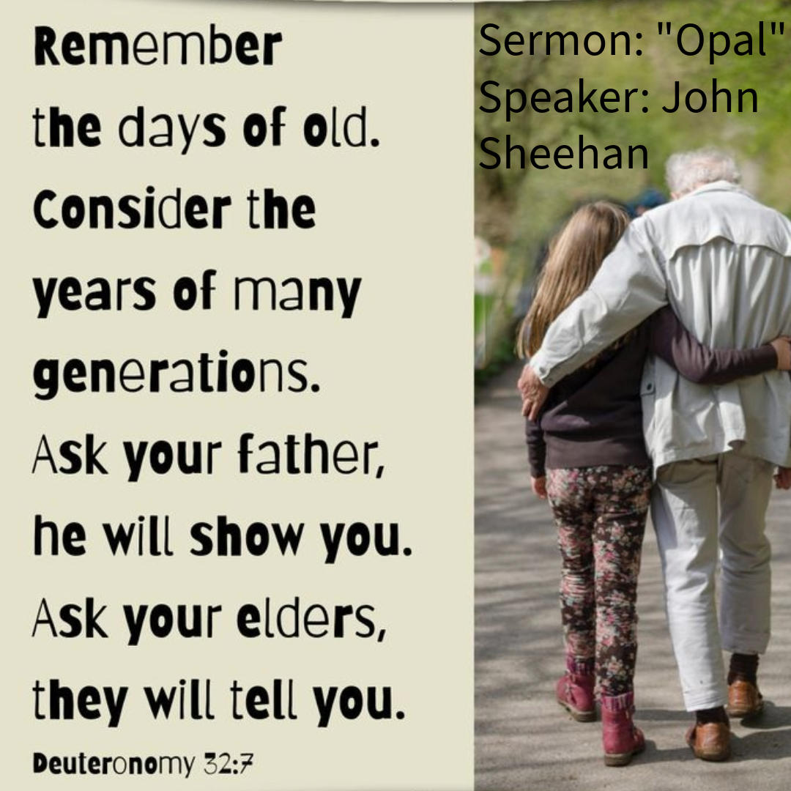
Wesley United Methodist Church
June 14, 2026
Deuteronomy 32:7

Remember the days of old;
consider the years long past;
ask your father, and he will inform you,
your elders, and they will tell you.

