Prelude – Give Thanks Loretta Ellis

Words of Welcome

╬ Call to Worship
We come before God, knowing our hearts are prone to wander.
Yet God’s mercy is greater than our sin.
When we fall, God invites us to return.
When we confess, God is faithful to forgive.
Let us turn our hearts toward the Lord.
We come seeking grace, renewal, and new life in Christ. Amen!

╬ Passing the Peace
All may greet one another in the name of the Lord.
╬ Come Thou Fount of Every Blessing № 400
Joys & Concerns
Pastoral Prayer
The Lord’s Prayer

Children’s Time

Bible Presentation

╬ Prayer for Illumination
Open our hearts to your Word.
Give us courage to see the sin within us,
humility to confess it, and faith to receive your mercy.
By your Holy Spirit, guide us into truth and transform our lives,
that we may turn from sin and walk more faithfully with you.
In Jesus’ name, Amen.

╬ Scripture: Romans 7:14 - 25

╬ Gloria Patri № 70

Sermon: The Message We Share: “Sin, Our Struggle”

Moments of Reflection

╬ Freely, Freely № 389

Tithes and Offerings
Offertory – ‘Tis so sweet to trust in Jesus Loretta Ellis
╬ Doxology № 95

╬ Prayer of Dedication
You have given us more than we can repay,
and you meet our weakness with grace. Receive these gifts as an expression of our gratitude and our desire to follow you more faithfully.
Turn our hearts from selfishness toward generosity, from sin toward holiness, and from ourselves toward you. In Christ’s name we pray. Amen

╬ I Want a Principle Within № 410

╬ Connections

╬ Benediction
Go forth in the grace of our Lord Jesus Christ, the love of God, and the communion of the Holy Spirit, turning from sin and walking in the way of Christ.
We go from here in faith, trusting God’s mercy, strengthened by the Holy Spirit, and seeking to serve the Lord. Amen!

Postlude – As The Deer Pants for the Water Loretta Ellis

CALENDAR OF EVENTS – WEEK OF September 13th- September 19th
Today 9:30 am Sunday Worship Bible Presentation Sunday
September 14th 4:45 pm Boot Camp at Calvary Life Center
September 15th 8 am & 4:45 pm Boot Camp at Calvary Life Center
6:00pm Boy Scouts at Calvary Life Center
September 16th 8am & 4:45pm Boot Camp at Calvary Life Center
5:30pm Mid – Week Manna at Wesley UMC
September 17th 8am & 4:45pm Boot Camp at Calvary Life Center
1:00 pm Prayer Shawls at Wesley UMC
4:30 pm TOPS at Calvary Life Center
September 18th 8:00am Boot Camp at Calvary Life Center
All Day Offices Closed
September 19th 2pm – 4pm Birthday Celebration Mary LaCrone
Gas Community Center
2pm – 9pm Gideon Camp Meeting at Calvary Life Center

OUR PRAYERS AND THOUGHTS
Please be in prayer for: Pittsburg Grace UMC, West Mineral UMC. Pastor Linda Stotler
Continuing Prayers: Spencer & Helen Ambler, Debbie Spait, Chris Callier, Beverly Franklin, Terry & Sandy Rodgers, Jerry Smith, David Wichman, Sandy Wolf - Buche, Vernon Miller, Maria (infant great-granddaughter of Larry & Pam Hart), Vic Edwards (Son-in-Law of Marvin & Donna Valentine), Craig Sargeant (Brenda Sargeant’s Son), Jack Stanley, Jeff Jackson (Norma Jackson’s Son), Matt Schwenk (Karen Lee’s Son-in-law), Penny Miller (Joann Miller’s Daughter), Becky Rourk, Donna Beebe, Donna Bauer, Brenda Seargent, Larry Robertson.
Care Home Residents: Baldwin Rehab: Cheryl Moyer. Greystone: Barbara Letsinger, Kathleen Sinclair, Dianna Cuppy, Eleanor Ross, Yvonne Dunlap. Oswego Health & Rehab: Lois Kerns. Pittsburg Health & Rehabilitation: Jan Powell. Medical Lodges: Deanna Buche- Wright Dignity Care Home: Joann Maxwell. Heartland: Jean Roberts. Hometouch: Debbi Sebbert, Don & Frances Wiles, Betty & Jerry Skidmore.

Pastor Owen is available by phone (620.228.1976), text, or email
(iolawesleypastor@gmail.com) Monday - Thursday during his office hours 9:00 - 3:30. After
hours, for emergency only. All prayer requests should be submitted to the church office by phone at 620.365.2285 or by email iolawesley@gmail.com
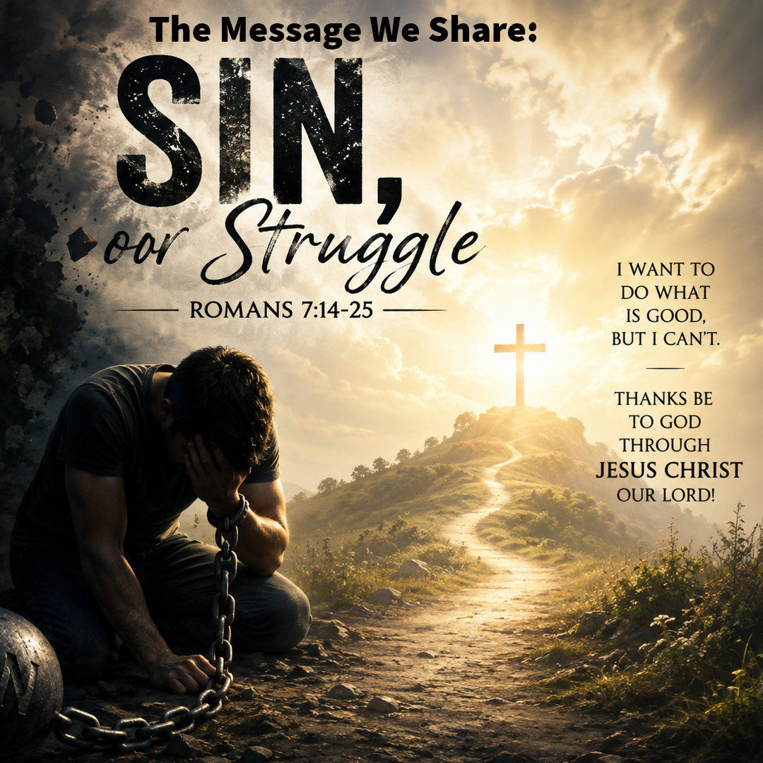
Wesley United Methodist Church
September 13, 2026
Romans 7:14 - 25
For we know that the law is spiritual, but I am of the flesh, sold into slavery under sin.^{[a]} ¹⁵ I do not understand my own actions. For I do not do what I want, but I do the very thing I hate. ¹⁶ Now if I do what I do not want, I agree that the law is good. ¹⁷ But in fact it is no longer I who do it but sin that dwells within me. ¹⁸ For I know that the good does not dwell within me, that is, in my flesh. For the desire to do the good lies close at hand, but not the ability. ¹⁹ For I do not do the good I want, but the evil I do not want is what I do. ²⁰ Now if I do what I do not want, it is no longer I who do it but sin that dwells within me.
²¹ So I find it to be a law that, when I want to do what is good, evil lies close at hand. ²² For I delight in the law of God in my inmost self, ²³ but I see in my members another law at war with the law of my mind, making me captive to the law of sin that dwells in my members. ²⁴ Wretched person that I am! Who will rescue me from this body of death? ²⁵ Thanks be to God^{[b]} through Jesus Christ our Lord!

